# ssh connection between two instances:

1. we should edit vi /etc/ssh/sshd/config as a root user and uncomment **PermitRootLogin** and **PasswordAuthentication** on both the machines.







1. Restart sshd using **systemctl restart sshd**
2. Create same user on both the machines like dockeradmin.
3. Give password using passwd dockeradmin
4. Add user on sudories on both the machines by using **visudo**

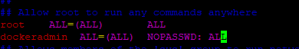

1. Login to user using **su - dockeradmin**
2. Generate ssh key and copy into target machine by using **ssh-keygen** and **ssh-copy-id**

Note: We should copy public IP into target machine.

1. Copy ssh key by using ssh-copy-id host_name(ip-172-31-7-193).
2. Check ssh connection between two machines by using **ssh host_name**
3. If you want to copy ssh key on same machine we should use **ssh-copy-id host_name** (same machine host_name)